Youth Recognition 2014 - 2015

The following lists include the girls who have received awards during the past Guiding year. Those with an asterisk * attended the Youth Recognition Ceremony held in Regina on October 25, 2015.
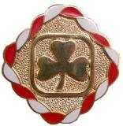
Congratulations, girls!

Canada Cord
The Canada Cord is the highest award a girl can earn as a Pathfinder.

Julia Christiansen*
Maggie Decosta*
Kaylee Dodds*
Nadine Gordon*
Michelle Harrison*
Tansley Hayes*
Lauren Hill*
Rowan Hollinger*
Kailey Knorr
Kyrissa Kuemper
Monique Lacroix*
Kiara Lundquist*
Makenna McClelland*
Bailey Mundell*
Kaitlyn Murphy
Jacy Nickel*
Alexa Osterried
Hannah Park*
Emily Peacock
Kylen Rioux
Megan Schmidt*
Michelle Thoresen*
Emily Turnbull

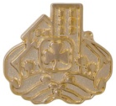
Community Service Pin
This pin is presented to Pathfinders upon completion of 15 hours of community service projects.

Michelle Harrison*
Kailey Knorr
Kyrissa Kuemper
Alexa Osterried
Emily Peacock
Kylen Rioux

Bronze Chief Commissioner Award
This award is presented to Rangers after completion of nine challenges
from at least four different program areas.

Melissa Bone
Samantha Brice*
McKenna Carswell*
Hope Crawford
Emily Eskowich
Breez Harley
Ali Janzen*
Kalli Kozar
Breanna Pochipinski
Kendall Schneider
Ashley Swirsky*
Syndel Thomas-Kozar
Katie Turnbull
Trista Yahyahkeekoot

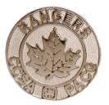
Silver Chief Commissioner Award
This award is presented to Rangers after completion of nine additional challenges from at least four areas.

Samantha Brice*
Sarah Neibergall

Kathryn Patterson
Ashley Swirsky*

Gold Chief Commissioner Award
This is the highest award a girl can earn as a Ranger.

Natashia Apangchan*
Vanessa Pratchler*

Commonwealth Award
This award is presented for completion of the challenge.

Natashia Apangchan*
Sarah Neibergall

Kathryn Patterson
Vanessa Pratchler*

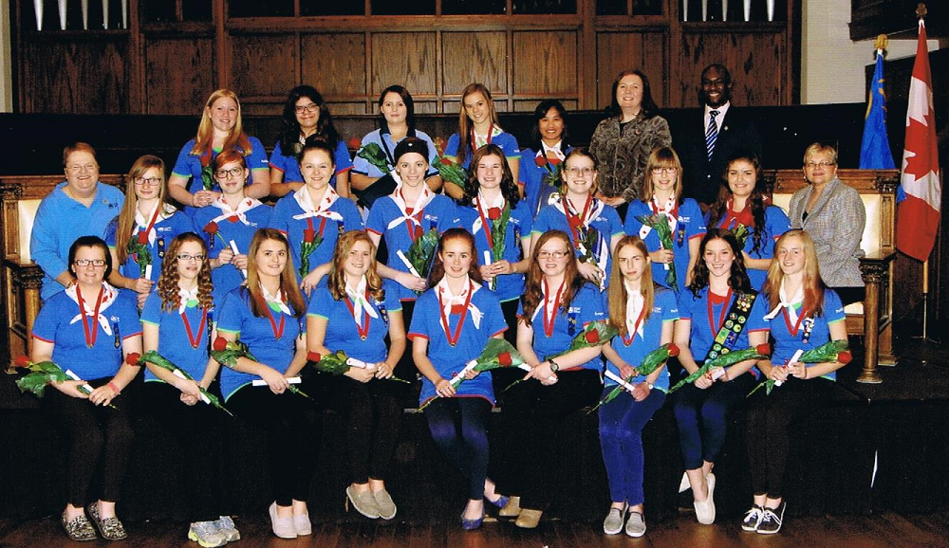
2015 Youth Recognition Ceremony

Back Row: L to R Lauren Hill, Ali Jansen, Vanessa Pratchler, Jacy Nickel, Natashia Apangchan, Sharron Brice – City Councillor, Partrick Brobbey – D of E Awards Officer
Middle Row: L to R Charlene McLean – P. C., Michelle Thoresen, McKenna Carswell, Ashley Swirsky, Samantha Brice, Monique Lacroix, Rowan Hollinger, Hanna Park, Megan Schmidt, Laura Ross – MLA
Front Row: L to R Bailey Mundell, Michelle Harrison, Nadine Gordon, Tansley Hayes, Kaylee Dodds, Julia Christiansen, Maggie DeCoste, Kiara Lundquist, Makenna McClelland.

